Freight Rate Prediction
Spotter Labs Machine Learning Engineer Assessment
Ayesha Shahid

1. Problem Overview
The task is a supervised regression problem: predict posted_rate, the dollar price of a freight load, from load characteristics (pickup, delivery, distance, equipment type, weight, and date). Three data files serve three distinct purposes. Train_test.csv (48,000 rows, January to October 2025) is the only labeled data available and is used for training and internal validation. Validation.csv (12,000 rows, November to December 2025) has no known posted_rate and is the file scored by Spotter. December_chart_inputs.csv (31 rows) is a single fixed lane, Lexington to Fort Wayne, where only the date changes across December, used to produce a sanity check chart rather than for accuracy grading.

2. Validation Approach: Train and Test Split
A random 80/20 split was deliberately not used. Train_test.csv spans January through October 2025, and the real prediction task, validation.csv, covers November and December 2025, a period after the end of the training data. A random split would place later rows into the training set while holding out earlier rows, meaning the model would sometimes be tested on data older than what it trained on. That is backwards relative to the real task and would leak information, making self-reported accuracy look better than it would in practice.
Instead, a time based holdout was used: the last 8 weeks of train_test.csv (September 6 to October 31, 2025) were held out as a stand in for the future, and the model was trained only on data before that window. This mirrors the actual task of predicting forward in time from known history. Once this approach was validated, the final submission model was refit on all of train_test.csv to use every available labeled row before predicting on validation.csv and december_chart_inputs.csv.
To check that the single 8 week holdout was not a lucky or unlucky window, a walk forward validation was also run using three expanding training windows, each validated on the following full calendar month. Results are in Section 6.

3. Data Quality

3.1 Negative weight values
292 rows in train_test.csv had negative weight values, with a minimum of negative 35,664. Freight weight cannot physically be negative, so this is unambiguously a sign flip data entry error rather than a genuine measurement. These rows were corrected using an absolute value transform rather than dropped, preserving the other valid columns in each row.

3.2 Missing values
Weight had 300 missing values in train_test.csv and 165 in validation.csv. These were imputed using the training set median, which is robust to the right skew typical of freight weight distributions (a median is not pulled toward extreme values the way a mean would be). Market_index had 374 missing values in train_test.csv; its missingness became moot once the feature was dropped entirely (Section 5).

3.3 Outliers in posted_rate
183 rows had posted_rate more than 3 standard deviations from the mean. These were flagged but kept, not removed. Unlike negative weight, an unusually high rate is not definitionally impossible; it could reflect a genuine oversized, rush, or long haul load. There was no domain basis to call these errors, and XGBoost's tree based splits are naturally more robust to outliers than a linear model would be, so no correction was applied.

4. Feature Engineering
Calendar features, month, day of week, and day of year, were extracted from the date column to capture seasonality and weekly pricing cycles. Pickup, delivery, and equipment were ordinal encoded to numeric codes for use in tree based models. Latitude and longitude columns were deliberately not used as separate features; distance already summarizes the geography as a single clean number, and adding four additional coordinate values would let the model attempt to relearn distance from scratch, adding noise without an accuracy benefit.

5. Feature Selection: Removing market_index and quote_signal
Market_index and quote_signal both showed near zero raw correlation with posted_rate, approximately 0.03 to 0.04. An ablation experiment, run with the same model configuration and holdout used for the final pipeline, confirmed that removing these two features improves holdout accuracy rather than hurting it:
Feature set | MAE | RMSE | MAPE
Full (includes market_index, quote_signal) | $158.33 | $666.92 | 8.80%
Structural only (dropped, final choice) | $153.22 | $666.18 | 7.09%

A near zero signal feature can still let a model fit noise patterns during training that do not hold up on new data, a mild form of overfitting. Removing pure noise features improved generalization. As a secondary benefit, this also means single model architecture serves both validation.csv, which includes market_index and quote_signal, and december_chart_inputs.csv, which never included them.
Distance is the strongest driver of the final model, accounting for approximately 79 to 80 percent of feature importance and correlating 0.91 with posted_rate. This describes the model's reliance on the feature, not a proven causal share of true cost, since correlation and feature importance are not the same as causality.

6. Model Selection
XGBoost was selected as the final model. The features involved, distance, weight, equipment, lane, and calendar signals, have a non-linear, interaction heavy relationship with posted_rate; this is exactly the setting where gradient boosted trees typically outperform linear models, and XGBoost is a standard choice for pricing and rate prediction on structured tabular data at this scale.
This was not an assumption; it was tested directly. Linear Regression (LR) and Random Forest (RF) were trained and evaluated on the identical 56 day temporal holdout used for the final model:
Model | MAE | RMSE | MAPE
Linear Regression | $192.64 | $662.87 | 11.99%
Random Forest | $182.63 | $718.91 | 8.18%
XGBoost (selected) | $152.90 | $666.36 | 7.05%

XGBoost wins clearly on Mean Absolute Error (MAE) and Mean Absolute Percentage Error (MAPE), the metrics that reflect typical prediction accuracy. RF higher Root Mean Squared Error (RMSE) suggests it struggles more on the extreme value loads discussed in Section 7, likely because XGBoost's sequential error correction handles hard cases better than RF averaging of independent trees.

7. Why RMSE Is Much Larger Than MAE
The final holdout produced MAE of $152.90 and RMSE of $666.36, a large gap worth explaining directly. The top 1 percent of holdout loads, 87 of 8,759 rows, averages a prediction error of $5,435, while the remaining 99 percent average just $99.90. Because RMSE squares each error before averaging, these extreme misses are amplified far more heavily than MAE would reflect.
Those 87 loads are long haul, cross country lanes, averaging 1,457 miles, with posted rates averaging $6,921, roughly 3 to 4 times higher than what distance based pricing predicts (for example, Baltimore to Oklahoma City and Montgomery to Fresno, where actual rates ran $17,000 to $20,000 against predictions near $4,000 to $6,000). MAE also rises steadily with distance, from about $49 under 200 miles to about $293 over 2,000 miles, consistent with error scaling alongside the size of the value being predicted.
Interpretation: MAE reflects the typical case experience for a load, roughly $153 off. RMSE reflects the model's sensitivity to a small number of high value long haul misses. A production version of this model would likely benefit from a long haul specific pricing component or additional distance interaction features to close this gap.

8. Robustness Check: Walk Forward Validation
A single 8 week holdout can understate real world variance. To check this, three walk forward folds were run, each with an expanding training window validated against the following full calendar month:
Validation month | Train rows | MAE | RMSE | MAPE
August 2025 | 33,718 | $190.42 | $656.07 | 9.83%
September 2025 | 38,477 | $185.29 | $692.26 | 7.81%
October 2025 | 43,147 | $250.90 | $722.56 | 13.88%

MAE across folds is $208.87 with a standard deviation (STD) of $36.49, and MAPE is 10.51 percent with a standard deviation of 3.09 percent. This is a more honest estimate of production performance than the single holdout window; the single window MAE of about $153 was somewhat optimistic. Notably, October, the fold with the most training data, had the worst error of the three, which is worth further investigation with more time, possibly reflecting a seasonal effect or a higher concentration of the extreme long haul loads described in Section 7.

9. December Fixed Lane Chart
The chart below was produced by Spotter's provided score.py after the final model predicted every row of december_chart_inputs.csv, a fixed lane, Lexington to Fort Wayne, 360 miles, Dry Van, 32,000 pounds, where only the date changes across all of December 2025.
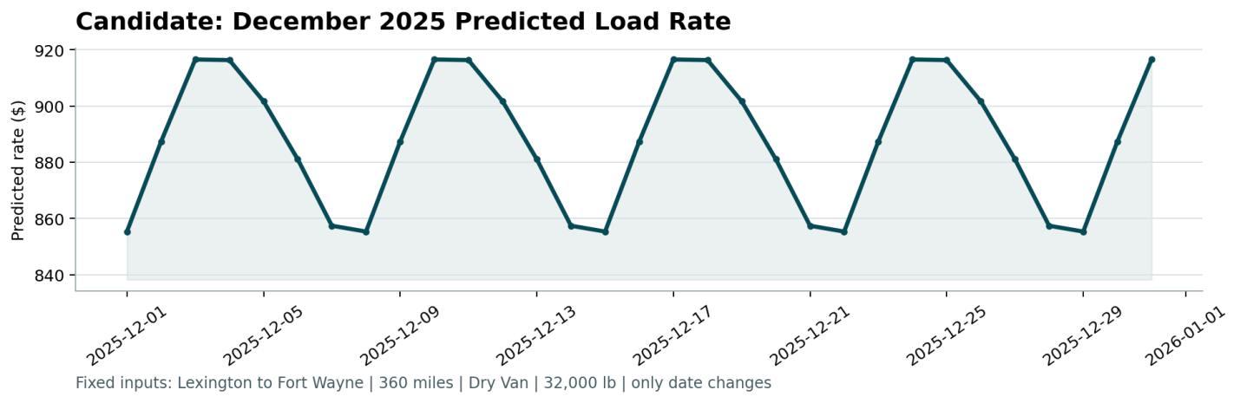
The chart shows a clean, repeating weekly cycle: predicted rates peak midweek, around $917, and dip on weekends, around $855. This matches the day of week calendar feature identified as a meaningful, if secondary; driver of rate in the feature importance results, and demonstrates that the model produces a sane, explainable trend even for a lane with minimal representation in the fixed inputs beyond date.

10. Business Interpretation
An MAE in the range of $150 to $210 per load, against a median posted_rate of about $2,055 in the holdout data, represents roughly 7 to 10 percent typical error, consistent with the MAPE figures reported above. For most loads this falls within a plausible day to day pricing tolerance. The practical risk is concentrated in the small subset of long haul loads identified in Section 7, where misses can run into the thousands of dollars and would matter most for margin on individual high value shipments. This suggests that while the current model is suitable for typical freight pricing, a production deployment would benefit from targeted improvements for the long haul segment specifically.

11. Summary
- Validation: Time based 8 week holdout, confirmed with 3 fold walk forward validation.
- Model: XGBoost, selected after direct comparison against LR and RF on the same holdout.
- Features: market_index and quote_signal dropped after an ablation showed they hurt generalization.
- Data quality: negative weight corrected, missing weight imputed, rate outliers flagged and retained.
- Final holdout metrics: MAE $152.90, RMSE $666.36, MAPE 7.05 percent.
- Walk forward metrics (more conservative): mean MAE $208.87, mean MAPE 10.51 percent.
- Error analysis: RMSE gap driven by long haul loads averaging 1,457 miles, a clear direction for future model improvement.

Final submission: the final model was retrained on all 48,000 labeled rows in train_test.csv and used to generate predictions for all 12,000 loads in validation.csv, submitted as validation_predictions.csv, and for all 31 rows of december_chart_inputs.csv.

